NewSensorFOVCalc Software
User Manual

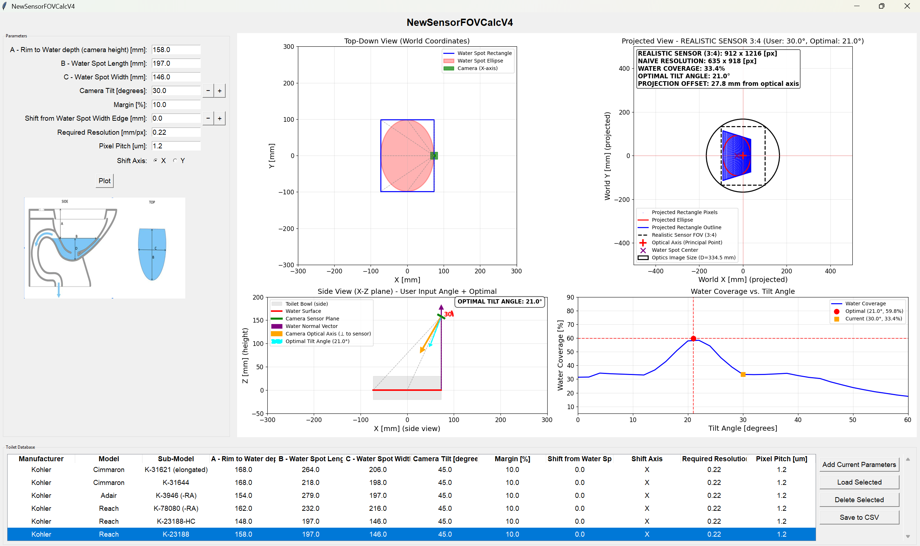

1. Overview and Purpose
1.1 Application Purpose
NewSensorFOVCalc simulates camera field-of-view projections over toilet bowl water surfaces to optimize camera positioning for maximum water coverage while meeting resolution resolving requirements.
1.2 Key Capabilities
- Real-time projection simulation with 4 visualization overlays
- Optimal parameter calculation for camera positioning
- Realistic sensor modeling using standard aspect ratios (3:2, 2:3, 4:3, 3:4)
- Database management for toilet configurations
- Interactive parameter adjustment with instant visual feedback

2. Input Parameters
2.1 Primary Input Parameters
Parameter | Symbol | Unit | Description | Typical Range
A | H | mm | Camera height above water surface (rim-to-water depth) | 100-200 mm
B | L | mm | Water spot length (Y-axis dimension) | 200-400 mm
C | W | mm | Water spot width (X-axis dimension) | 200-350 mm
Tilt | θ | degrees | Camera tilt angle from vertical | 0° to 65°
Margin | M | % | Safety margin around water coverage | 5-20%
Shift | S | mm | Lateral camera offset from water edge | -50 to +50 mm
ShiftAxis | axis | X/Y | Direction of camera shift (X or Y axis) | X or Y
Resolution | R | mm/px | Required image resolution | 0.1-0.5 mm/px
PixelPitch | PP | μm | Physical sensor pixel size | 1.0-3.0 μm

3. Core Calculations
3.1 Camera Position Calculation
From Input Parameters to 3D Position:
Step 1: Determine camera coordinates using input parameters
Water ellipse center: (0, 0, 0)
Water ellipse semi-axes: (C/2, B/2)
Step 2: Calculate camera position
Height above water = A
Lateral position depends on Shift and ShiftAxis:
- X-axis shift: CameraX at (C/2 + Shift, 0, A), CameraY=0
- Y-axis shift: CameraY at (0, B/2 + Shift, A), CameraX=0

3.2 Optical Axis Calculation from Tilt
Converting Tilt Angle to Camera Orientation:
Step 1: Start with vertical optical axis = (0, 0, -1) (looking downward)
Step 2: Apply rotation based on ShiftAxis and Tilt
If ShiftAxis = "X": Optical_Axis =(sinθ,0,−cosθ)
Optical_X = sin(Tilt × π/180)
Optical_Y = 0
Optical_Z = -cos(Tilt × π/180)
If ShiftAxis = "Y": Optical_Axis =(0,−sinθ,−cosθ)
Optical_X = 0
Optical_Y = -sin(Tilt × π/180)
Optical_Z = -cos(Tilt × π/180)
3.3 Water Point Projection
Converting 3D Water Points to 2D Camera Image:
For any water surface point (x, y, 0):
Step 1: Calculate vector from camera to point
Vector = (x - Camera_X, y - Camera_Y, 0 - Camera_Z)
Step 2: Project using camera parameters
Depth = Vector · Optical_Axis
Image_X = (Vector · Camera_X_Axis / Depth) × A
Image_Y = (Vector · Camera_Y_Axis / Depth) × A
Result: Water point appears at (Image_X, Image_Y) on sensor

3.4 Sensor Selection Algorithm
Choosing Optimal Sensor from Standard Ratios:
Allowed sensor aspect ratios: 3:2, 2:3, 4:3, 3:4
Step 1: Calculate required sensor size
Required_Width = max(projected water width) × (1 + Margin/100)
Required_Height = max(projected water height) × (1 + Margin/100)
Step 2: Test each standard ratio
For each ratio in [3:2, 2:3, 4:3, 3:4]:
Calculate minimum sensor size that fits requirements
Select ratio with smallest total area
Step 3: Apply safety margin
Final_Sensor_Width = Selected_Width × (1 + Margin/100)
Final_Sensor_Height = Selected_Height × (1 + Margin/100)
3.5 Resolution Calculation
Converting Physical Dimensions to Pixels:
Step 1: Calculate sensor physical dimensions
Sensor_Width_mm = 2 × Sensor_Half_Width
Sensor_Height_mm = 2 × Sensor_Half_Height
Step 2: Convert to pixel count
Pixels_X = Sensor_Width_mm / Resolution
Pixels_Y = Sensor_Height_mm / Resolution
Step 3: Validate against pixel pitch
Physical_Pixel_Size = Resolution × 1000 (convert mm to μm)
Check: Physical_Pixel_Size ≥ PixelPitch (feasibility)

3.6 Water Coverage Calculation
Measuring Sensor Efficiency:
Step 1: Create virtual sensor grid (100×100 points)
For each point (i, j) in sensor grid:
Sensor_X = (i/100) × Sensor_Width - Sensor_Width/2
Sensor_Y = (j/100) × Sensor_Height - Sensor_Height/2
Step 2: Test if point covers water
Relative_X = Sensor_X - Water_Center_X
Relative_Y = Sensor_Y - Water_Center_Y
If (Relative_X/Water_Half_Width)² + (Relative_Y/Water_Half_Height)² ≤ 1:
Point covers water (count it)
Step 3: Calculate coverage percentage
Coverage = (Water_Points / Total_Points) × 100
3.7 Optimal Tilt Angle Discovery
Finding Maximum Coverage Configuration:
Step 1: Define search range (typically 0° to 60°)
Best_Coverage = 0
Best_Angle = 0
Step 2: Test each angle in 1° increments
For Angle = 0 to 60:
Set test parameters = input parameters
Set test Tilt = Angle
Calculate water coverage using steps 3.1-3.6
If coverage > Best_Coverage:
Best_Coverage = coverage
Best_Angle = Angle
Step 3: Return optimal configuration
Optimal_Tilt = Best_Angle
Maximum_Coverage = Best_Coverage

4. Visualization Overlays
4.1 Top-Down View (World Coordinates)
Display Elements:
- Water ellipse: Shows actual water surface (C × B dimensions)
- Camera position: Square marker at calculated camera location
- FOV lines: Dashed lines from camera to water edges
- Coordinate grid: World X,Y coordinates in millimeters
Purpose: Visualize camera placement relative to toilet geometry
4.2 Projected View (Camera Image Plane)
Display Elements:
- Projected water ellipse: Water surface as seen by camera
- Sensor boundaries: Realistic sensor FOV rectangle
- Optical axis: Red crosshairs at (0,0) principal point
- Water center: Purple marker showing projection center offset
- Information overlay: Real-time calculations display
Information Overlay Content:
REALISTIC SENSOR (aspect ratio): width × height pixels
NAIVE RESOLUTION: width × height pixels
WATER COVERAGE: percentage%
OPTIMAL TILT ANGLE: degrees°
PROJECTION OFFSET: distance mm from optical axis
4.3 Side View (Cross-Section)
Display Elements:
- Toilet bowl: Gray rectangle representing bowl cross-section
- Water surface: Red line at Z=0
- Camera sensor: Colored line showing sensor orientation
- Optical axis: Orange arrow showing camera pointing direction
- Optimal axis: Cyan dashed arrow showing ideal direction
- Tilt angle arc: Red arc with angle measurement
- Normal vector: Purple arrow showing water surface normal
Purpose: Visualize camera tilt and height relationships
4.4 Coverage Curve (Performance Analysis)
Display Elements:
- Blue curve: Water coverage percentage vs. tilt angle (0-60°)
- Red point: Optimal angle with maximum coverage
- Orange square: Current user angle and its coverage
- Grid lines: Horizontal/vertical references for optimal point
Y-axis range: 5-90% (focused on practical range)
X-axis range: 0-60° (practical tilt angles)

5. User Interface Guide
5.1 Parameter Input Panel
Parameter Entry:
- Text fields for numeric inputs (A, B, C, Tilt, Margin, Shift, Resolution, PixelPitch)
- Radio buttons for ShiftAxis selection (X or Y)
- Increment/decrement buttons for Tilt (±1°) and Shift (±5mm)
Real-time Updates:
- All overlays update automatically when radio buttons change
- Manual updates via "Plot" button for text field changes
5.2 Database Operations
Available Functions:
- Add Current Parameters: Save current configuration to database
- Load Selected: Apply selected database entry to parameters
- Delete Selected: Remove entry from database
- Save to CSV: Export complete database
Duplicate Detection: System prevents saving identical technical parameters
5.3 Font and Display Controls
Customizable Elements:
# Font size variables (top of main.py)
GRAPH_TITLE_FONTSIZE = 14 # Main plot titles
GRAPH_LABEL_FONTSIZE = 14 # Axis labels
GRAPH_TICK_FONTSIZE = 12 # Axis tick numbers
GRAPH_LEGEND_FONTSIZE = 10 # Legend text
GRAPH_OVERLAY_FONTSIZE = 12 # Information overlays

6. Technical Specifications
6.1 Coordinate Systems
World Coordinates:
- Origin: Water surface center (0, 0, 0)
- X-axis: Water width direction
- Y-axis: Water length direction
- Z-axis: Vertical height (positive upward)
Camera Coordinates:
- Origin: Camera position
- Z-axis: Along optical axis (toward scene)
- X,Y-axes: Perpendicular to optical axis
6.2 Mathematical Models
Water Surface Geometry:
- Shape: Ellipse with semi-axes (C/2, B/2)
- Height: Z = 0 (reference plane)
- Area: π × (C/2) × (B/2)
Camera Model:
- Type: Pinhole perspective projection
- Focal length: Camera height (A parameter)
- Principal point: Image center (0, 0)
Sensor Constraints:
- Standard aspect ratios only: 3:2, 2:3, 4:3, 3:4
- Physical pixel pitch limits
- Manufacturing feasibility checks
6.3 Algorithm Performance
Optimization Search:
- Tilt angle range: 0° to 60° in 1° steps
- Coverage calculation: 100×100 grid sampling
- Convergence: Global maximum detection
Real-time Updates:
- Projection calculations: <10ms typical
- Coverage analysis: <100ms typical
- Display refresh: <50ms typical

7. Usage Workflow
7.1 Basic Setup Procedure
Step 1: Measure toilet dimensions
Enter A (rim-to-water depth)
Enter B (water spot length)
Enter C (water spot width)
Step 2: Set camera constraints
Enter required Resolution (mm/px)
Enter sensor PixelPitch (μm)
Select ShiftAxis (X or Y)
Step 3: Optimize positioning
Adjust Tilt angle while watching coverage curve
Fine-tune Shift offset for centering
Set appropriate Margin for safety
Step 4: Validate results
Check all four overlays for consistency
Verify sensor resolution is feasible
Confirm coverage percentage is acceptable
7.2 Optimization Strategy
1. Start with default values
2. Click "Plot" to see initial configuration
3. Observe optimal angle in coverage curve (red point)
4. Adjust Tilt toward optimal value
5. Fine-tune Shift for best centering
6. Increase Margin if needed for robustness
7. Save successful configuration to database
7.3 Troubleshooting Guide
Issue | Cause | Solution
Low coverage % | Camera too far/wrong angle | Reduce A or adjust Tilt toward optimal
Ellipse cutoff | Insufficient sensor size | Increase Margin or change aspect ratio
High pixel count | Too high resolution requirement | Increase Resolution value (mm/px)
No optimal point | Extreme geometry | Check A, B, C values for realism
Plot not updating | Invalid parameters | Verify all numeric inputs

8. Advanced Features
8.1 Comparative Analysis
Multi-Configuration Comparison:
- Save baseline configuration to database
- Modify parameters (e.g., different camera height)
- Compare coverage percentages and sensor requirements
- Select optimal configuration based on constraints
8.2 Sensitivity Analysis
Parameter Impact Assessment:
- Height (A): Higher = smaller projection, lower coverage
- Tilt: Optimal value maximizes coverage, extremes reduce it
- Shift: Centers projection, reduces optical axis offset
- Margin: Increases sensor size, improves robustness
8.3 Manufacturing Constraints
Sensor Feasibility Checks:
- Physical pixel size must be ≥ specified PixelPitch
- Total pixel count should be reasonable (<10MP typically)
- Aspect ratio must match standard sensors (3:2, 2:3, 4:3, 3:4)

9. Output Interpretation
9.1 Key Performance Metrics
Primary Outputs:
- Water Coverage %: Efficiency of sensor utilization
- Sensor Resolution: Required pixel dimensions
- Optimal Tilt Angle: Best camera orientation
- Projection Offset: Misalignment from optical center
Target Values:
- Coverage: >70% for good efficiency
- Resolution: <3000×3000 pixels for practicality
- Offset: <50mm for reasonable optics size
9.2 Decision Criteria
Configuration Selection:
- Maximum coverage while meeting resolution requirements
- Standard sensor availability (preferred aspect ratios)
- Reasonable pixel count for cost-effective implementation
- Minimal optical complexity (small offset, reasonable FOV)

10. Conclusion
NewSensorFOVCalc provides comprehensive camera system design capabilities through:
- Physics-based projection modeling using standard pinhole camera equations
- Real-time optimization with visual feedback across four synchronized overlays
- Practical constraints including realistic sensor specifications and manufacturing limits
- Database management for comparison of toilet configurations and camera setups
The software enables engineers to design optimal camera positioning systems for toilet inspection applications while ensuring technical feasibility and cost-effectiveness.
Key Benefits:
- Eliminates guesswork in camera positioning
- Maximizes water surface coverage efficiency
- Ensures manufacturable sensor specifications
- Provides visual confirmation of design decisions
- Enables systematic comparison of alternatives
⁂

